Miss Vick’s Spelling Group - Term 4

Dear Parents/Carers

These are your children’s spellings for this term. We introduce the new rule in class on a Monday and we practise throughout the week. These spellings are then tested the following Monday. There will also be one tricky word from the Year 3 and 4 list to practise a week. Please support your child’s learning by helping them to practise these at home. 😊

|  |
| --- |
| **Introduced week beginning**: 20.02.23  **Tested on:** 27.02.23 |
| **Spelling rule**: Adding ly  If the word ends with l, just add ly real 🡪 really  If the word ends with e, just add ly love 🡪 lovely  If the word ends with le, change le to ly simple 🡪 simply |

|  |  |  |  |  |
| --- | --- | --- | --- | --- |
|  | **Read** | **Copy** | **Cover** | **Check** |
| **1** | equally |  |  |  |
| **2** | fearfully |  |  |  |
| **3** | bubbly |  |  |  |
| **4** | normally |  |  |  |
| **5** | locally |  |  |  |
| **6** | drizzly |  |  |  |
| **7** | politely |  |  |  |
| **8** | falsely |  |  |  |
| **9** | totally |  |  |  |
| **10** | wrinkly |  |  |  |
| **11** | consider |  |  |  |

Challenge: write a silly sentence using at least 4 words from this week’s spellings. Include an illustration too!

|  |
| --- |
| **Introduced week beginning: 27.03**.2023  **Tested on:** 06.03.2023 |
| **Spelling rule**: Topic words 2.  Take the word apart and try to find the tricky bit.  You could colour block the word to help you remember the spelling 🡪 electricity |

|  |  |  |  |  |
| --- | --- | --- | --- | --- |
|  | **Read** | **Copy** | **Cover** | **Check** |
| **1** | electricity |  |  |  |
| **2** | circuit |  |  |  |
| **3** | battery |  |  |  |
| **4** | magnet |  |  |  |
| **5** | attract |  |  |  |
| **6** | repel |  |  |  |
| **7** | opposite |  |  |  |
| **8** | diagram |  |  |  |
| **9** | material |  |  |  |
| **10** | insulate |  |  |  |
| **11** | possible |  |  |  |

Challenge: write a poem about magnets or electricity using this week’s spellings

|  |
| --- |
| **Introduced week beginning: 06**.03.2023  **Tested on:** 13.03.2023 |
| Spelling rule: adding ing and ed    clapped tripping  live 🡪 living  hope 🡪 hoped  carry 🡪 carried  carry 🡪 carrying |

|  |  |  |  |  |
| --- | --- | --- | --- | --- |
|  | **Read** | **Copy** | **Cover** | **Check** |
| **1** | escaping |  |  |  |
| **2** | denied |  |  |  |
| **3** | terrifying |  |  |  |
| **4** | terrified |  |  |  |
| **5** | relaxed |  |  |  |
| **6** | forgetting |  |  |  |
| **7** | trapped |  |  |  |
| **8** | discovering |  |  |  |
| **9** | glistened |  |  |  |
| **10** | improving |  |  |  |
| **11** | favourite |  |  |  |

Challenge: write a sentence in past tense about being on a tropical island using some of this week’s spelling.

|  |
| --- |
| **Introduced week beginning: 13.03**.2023  **Tested on:** 20.03.23 |
| Spelling rule: adjective suffixes  Adding these suffixes makes words into adjectives : al ic able ive  Musical graphic breakable explosive |

|  |  |  |  |  |
| --- | --- | --- | --- | --- |
|  | **Read** | **Copy** | **Cover** | **Check** |
| **1** | metallic |  |  |  |
| **2** | tropical |  |  |  |
| **3** | poetic |  |  |  |
| **4** | historic |  |  |  |
| **5** | massive |  |  |  |
| **6** | magnetic |  |  |  |
| **7** | heroic |  |  |  |
| **8** | comfortable |  |  |  |
| **9** | accidental |  |  |  |
| **10** | electrical |  |  |  |
| **11** | build |  |  |  |

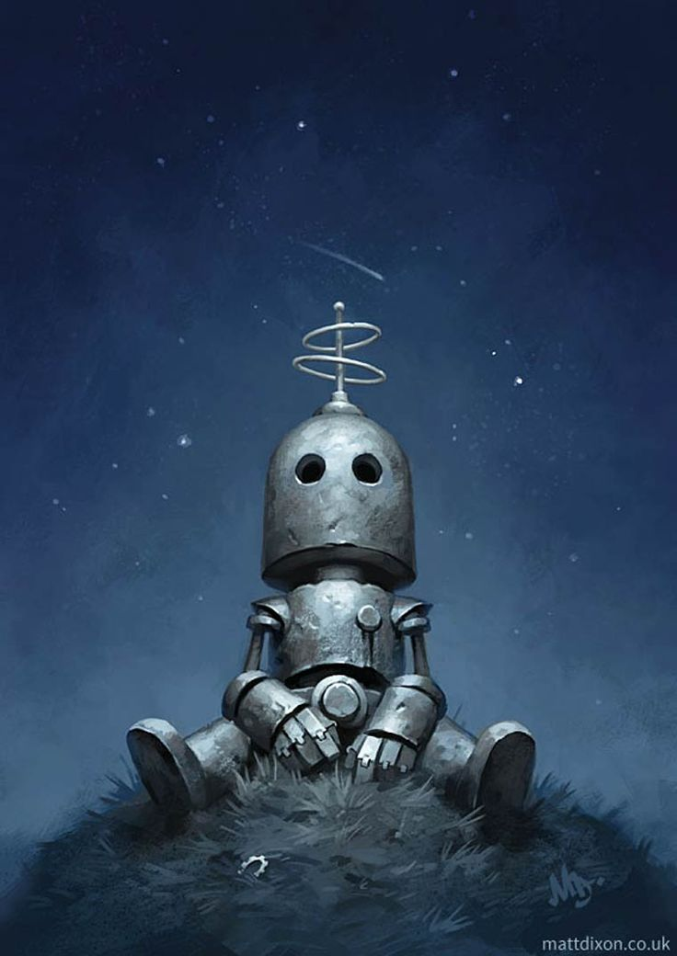

Challenge: describe this robot using at least three of the words from this week’s spelling.

|  |
| --- |
| **Introduced week beginning:** 20.03.23  **Tested on: 27.03.23** |
| **Spelling rule:** verb suffixes  The suffixes  **ise ify ate en** make words into verbs  finalise glorify educate weaken |

|  |  |  |  |  |
| --- | --- | --- | --- | --- |
|  | **read** | **Copy** | **Cover** | **Check** |
| **1** | sweeten |  |  |  |
| **2** | memorise |  |  |  |
| **3** | simplify |  |  |  |
| **4** | decorate |  |  |  |
| **5** | realise |  |  |  |
| **6** | straighten |  |  |  |
| **7** | quieten |  |  |  |
| **8** | advertise |  |  |  |
| **9** | justify |  |  |  |
| **10** | elasticate |  |  |  |
| **11** | disappear |  |  |  |

Challenge: write some of these words as an illustration for what they mean…

Example:

|  |
| --- |
| **Introduced week beginning:** 27.03.23  **Tested after half term** |
| A review of this term’s spellings (and three tricky words) |

|  |  |  |  |  |
| --- | --- | --- | --- | --- |
|  | **read** | **Copy** | **Cover** | **Check** |
| **1** | equally |  |  |  |
| **2** | electricity |  |  |  |
| **3** | disappear |  |  |  |
| **4** | straighten |  |  |  |
| **5** | heroic |  |  |  |
| **6** | metallic |  |  |  |
| **7** | terrified |  |  |  |
| **8** | improving |  |  |  |
| **9** | trapped |  |  |  |
| **10** | memorise |  |  |  |
| **11** | probably |  |  |  |
| **12** | century |  |  |  |
| **13** | eighth |  |  |  |